Car

Game Template

Game documentation and How To guide.

\

# **Car game is a full Unity template ready for release. It is fun arcade game. It is compatible with mobile( iOS and Android) as well as standalone and webplayer.**

**How to Play?**

- Control the Car with arrow keys or touch.   
- Collect all the circles and avoid the squares on the road.

**Please rate my file, I’d appreciate it**



Customization Guide

First of all, you have to get [DOTWEEN](http://u3d.as/aZ1) from the Asset Store :

<http://u3d.as/aZ1>

(it’s free)

1/ Import Dotween from the asset store : <http://u3d.as/aZ1>

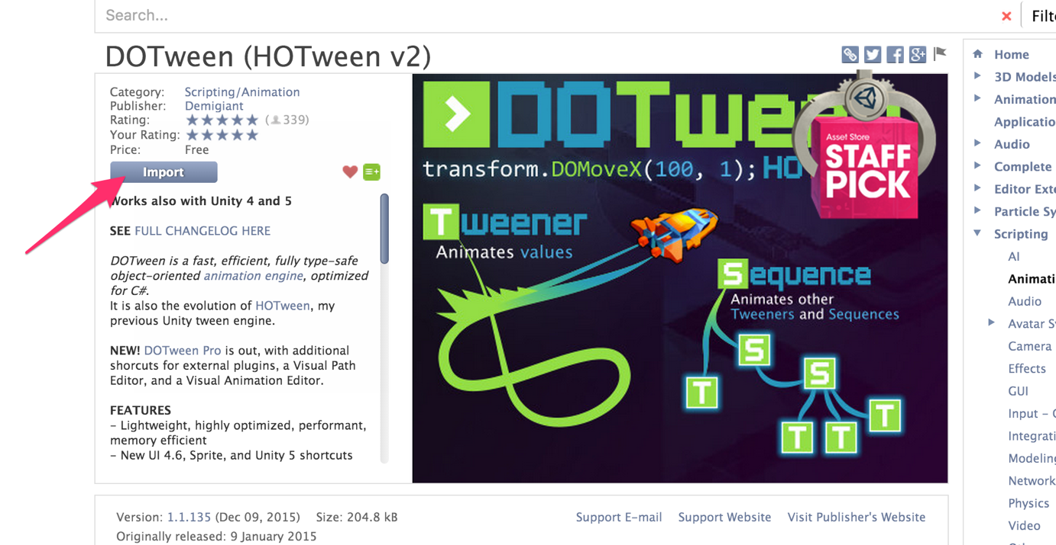

2/ Import the package into Unity

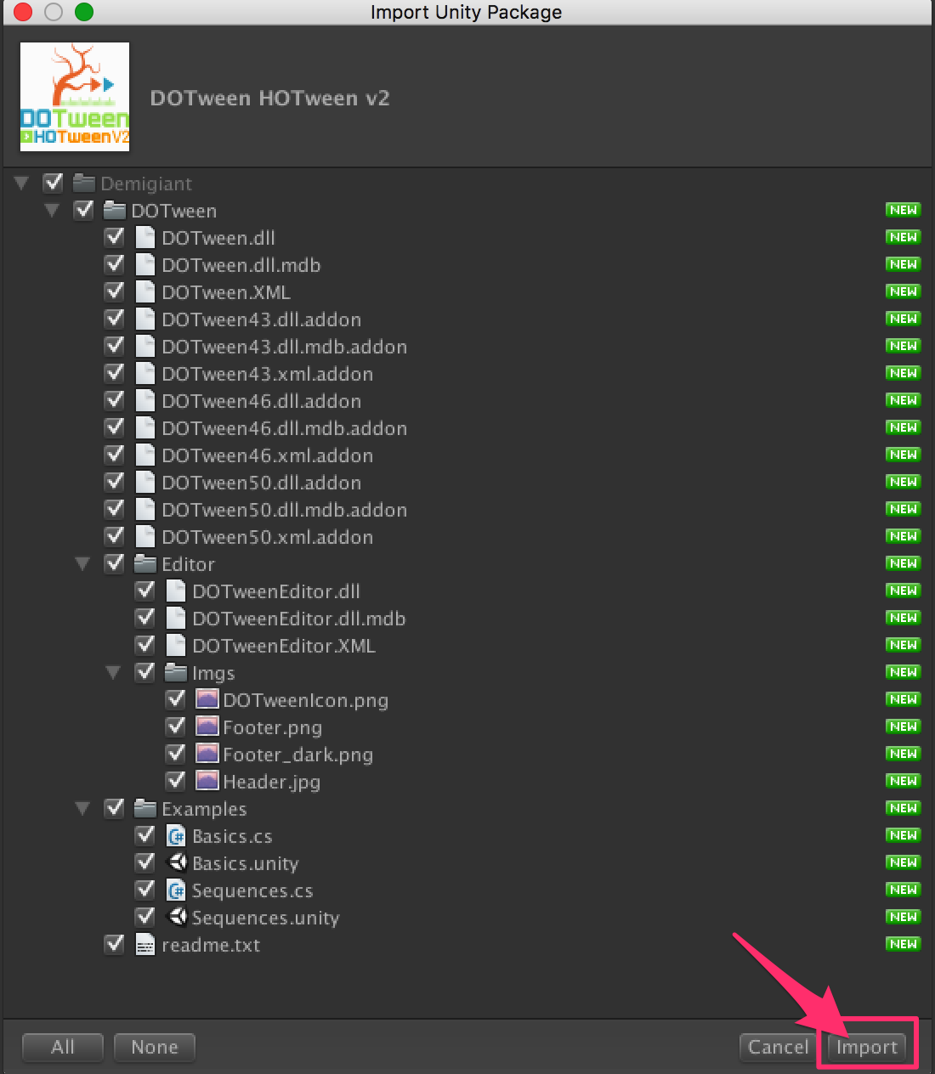

3/If you don’t see the « Tools » in the top of the Unity Screen, please do this :

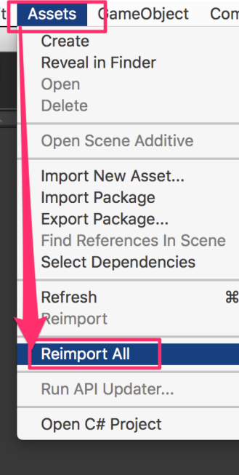

4/Now you have the « Tools ». Open it and click on « DOTween Utility Panel ».

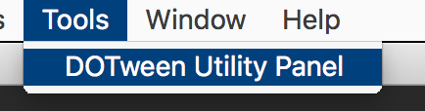

5/Click on « Setup DOTween ».

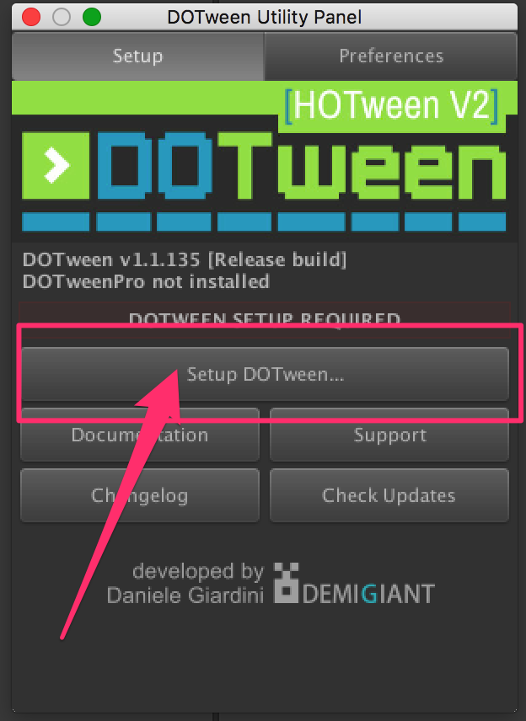

6/And to finish, click on the « OK » button.

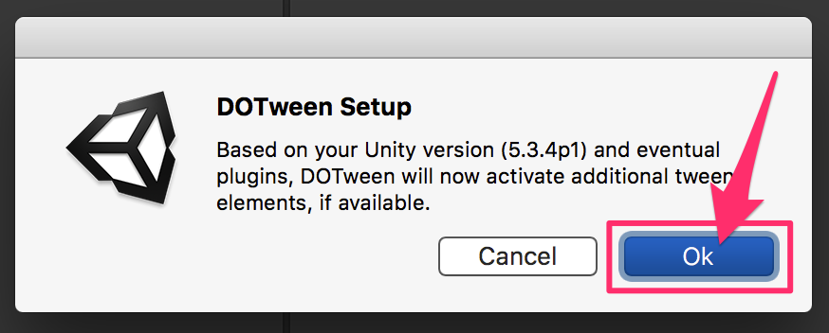

GameController

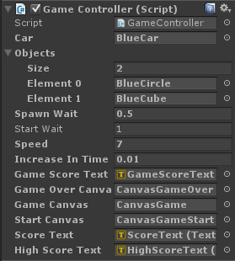

**Car:** Contains the Car GameObject.

**Objects:** cubes & circle prefab is placed here which is created during the gameplay.

**Spawn Wait:** the wait(in seconds) between two gameObject creation.

**Start Wait:** the wait(in seconds) before initial wave start.

**Speed:** speed at which Circles & Cubes move.

**Increase in Time Speed:** increase in time scale after every spawn.

**Game Score Text:** holds the current score text.

**Game Over Canvas:** holds the game over canvas.

**Game Canvas:** holds the Game canvas.

**Start Canvas:** holds the StartGame canvas.

**Score Text:** holds the score text.

**High Score Text:** holds the HighScore text.

Using orange theme

1) open the prefabs folder

2)drag orangeCar to Car in gamecontroller.

3)drag orangeCircle to element in objects of gamecontroller.

4)drag orangeCube to element in objects of gamecontroller.

For any enquiry contact: **aakarshak51@gmail.com**